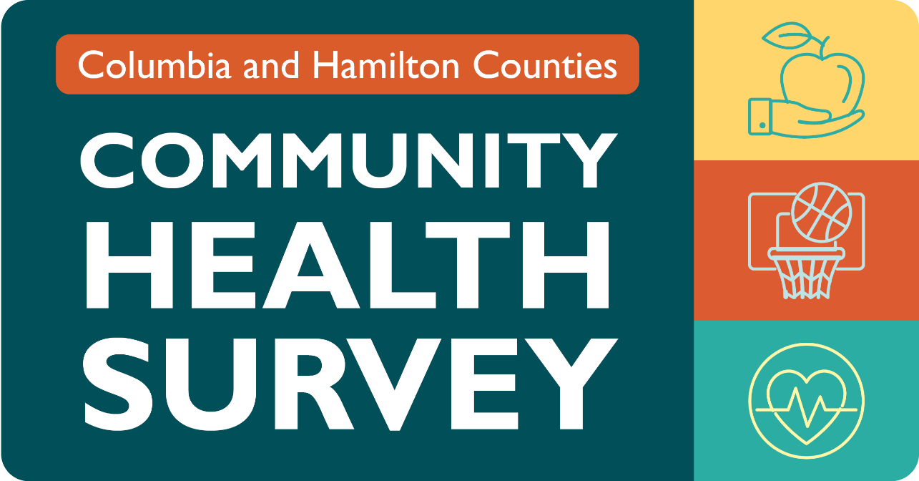
Columbia and Hamilton Counties: Community Health Needs Assessment Survey
Columbia and Hamilton County residents, community partners, and providers of health and social services are invited to share their views on health and healthcare by taking a brief survey. The survey is available in English and Spanish from February 14 through March 31. Survey results, along with local health data, will be used to develop a Community Health Needs Assessment. This report will identify the most pressing health issues in the region and serve as a tool for community leaders to take action. Your voice matters!
Community Members may take the survey at https://www.wellflorida.org/surveys/
Providers/Community Partners may take the survey at https://www.wellflorida.org/surveys/
For more information about the Community Health Survey, contact Christine Abarca, MPH, at cabarca@wellflorida.org or 352-313-6500 x8101. WellFlorida Council, the local health planning council, is conducting these surveys in Columbia and Hamilton counties.

